WEBSITE QUALITY ASSURANCE (QA) AUDIT REPORT

Project: Cynbit Technologies Website Quality Audit
Website: https://www.cynbit.in/
Assessment: QA Testing Intern – Technical Assessment
Report Type: Preliminary QA Audit Report
Prepared by: Garima Rawat
Date of Testing: 1/11/ 2026
Device: Samsung Galaxy A52
Browser: Google Chrome, version- 155.0.8059.84
Operating System: Android 14

1. Introduction

The purpose of this quality assurance audit is to review the Cynbit Technologies website and identify possible issues related to navigation, functionality, usability and user experience.
The audit focuses on observing how website elements respond to user actions and documenting any issues noticed during testing. The findings in this report are based on the testing observations recorded by the candidate.

2. Objectives of the Audit

- To review the website's navigation and important links.
- To identify elements that do not respond as expected.
- To observe the general usability of the website.
- To identify possible issues affecting the user experience.
- To prepare a structured bug report.
- To recommend improvements for website quality.

3. Scope of Testing

The following areas are included in the planned audit:
Testing Area | Description
Navigation Testing | Checking menu items and internal page links
Functional Testing | Checking whether clickable elements respond
Usability Testing | Reviewing ease of navigation and user experience
Responsiveness Testing | Checking layout on different screen sizes
Content Review | Checking visible text, headings and page information
Compatibility Testing | Planning checks across browsers and devices

4. Testing Methodology

The audit follows a basic manual testing approach.
1. Open the website in a browser.
2. Review the homepage and visible navigation menu.
3. Tap the Careers navigation item.
4. Observe whether the expected page or response appears.
5. Return to the website and tap the Case Studies navigation item.
6. Observe whether the expected page or response appears.
7. Record the observed result.
8. Classify the issue and suggest a possible improvement.
9. Retest the issue after any correction.

5. Test Environment

Parameter | Details
Website | https://www.cynbit.in/
Device Type | Android mobile phone
Device Model | Samsung Galaxy A52
Operating System | Android 14
Browser Version | 155.0.8059.84
Screen Resolution | 1080x2400 pixels
Network | 4G Lite
Browser | Google Chrome
Testing Type | Manual Testing
Testing Status | Preliminary

6. Preliminary Test Observations

Observation 1: Careers Navigation
Test ID: TC-001
- Observed Behaviour: When the Careers navigation item was tapped, no visible response was observed by the tester.
- Expected Behaviour: The Careers link should open the Careers page or provide a clear response.
- Actual Behaviour: No visible response was observed after tapping the link.
- Status: Preliminary issue – requires reproduction and verification.

Observation 2: Case Studies Navigation
Test ID: TC-002
- Observed Behaviour: When the Case Studies navigation item was tapped, no visible response was observed by the tester.
- Expected Behaviour: The Case Studies link should open the relevant page or provide a clear response.
- Actual Behaviour: No visible response was observed after tapping the link.
- Status: Preliminary issue – requires reproduction and verification.

7. Bug Summary

Two potential navigation issues have been reported during the initial mobile check.
Bug ID | Issue | Severity (Provisional) | Status
BUG-001 | Careers navigation does not show a visible response after tapping | Medium | Verified
BUG-002 | Case Studies navigation does not show a visible response after tapping | Medium | Verified

8. Recommendations

- High-Priority Recommendations
- Verify the Careers and Case Studies navigation links on mobile.
- Confirm that each navigation item opens the correct destination.
- Check whether the links have valid destinations.
- Retest the navigation after any correction.

- Medium-Priority Recommendations
- Review the mobile navigation menu behaviour.
- Check that clickable items provide clear feedback.
- Test the website on different screen sizes.
- Check the website on more than one browser.

- General Recommendations
- Perform regular manual testing after website updates.
- Maintain a bug tracking register.
- Capture screenshots for reproducible issues.
- Retest fixed issues before closing them.
- Conduct periodic usability and responsiveness checks.

9. Test Coverage Matrix
Test Category | Planned Test | Current Test
Homepage | Open and review homepage | Not fully documented
Careers Navigation | Tap Careers menu item | Preliminary issue reported
Case Study Navigation | Tap Case Studies menu item | Preliminary issue reported
Other Navigation Links | Check remaining menu items | Not Run
Forms | Check form submission and validation | Not Run
Images | Check image loading | Not Run
Responsiveness | Check multiple screen sizes | Not Run
Browser Compatibility | Check multiple browsers | Not Run
Content | Review spelling and visible content | Not Run

10. Conclusion

The preliminary audit recorded two user-reported navigation concerns involving the Careers and Case Studies menu items on an Android mobile device. Both observations require further reproduction and verification before they can be treated as confirmed defects.

Additional functional, usability, responsiveness and browser compatibility testing is still required. The findings and recommendations in this report are intended to support further testing and improve the overall quality of the website.

11. Evidence and Screenshots

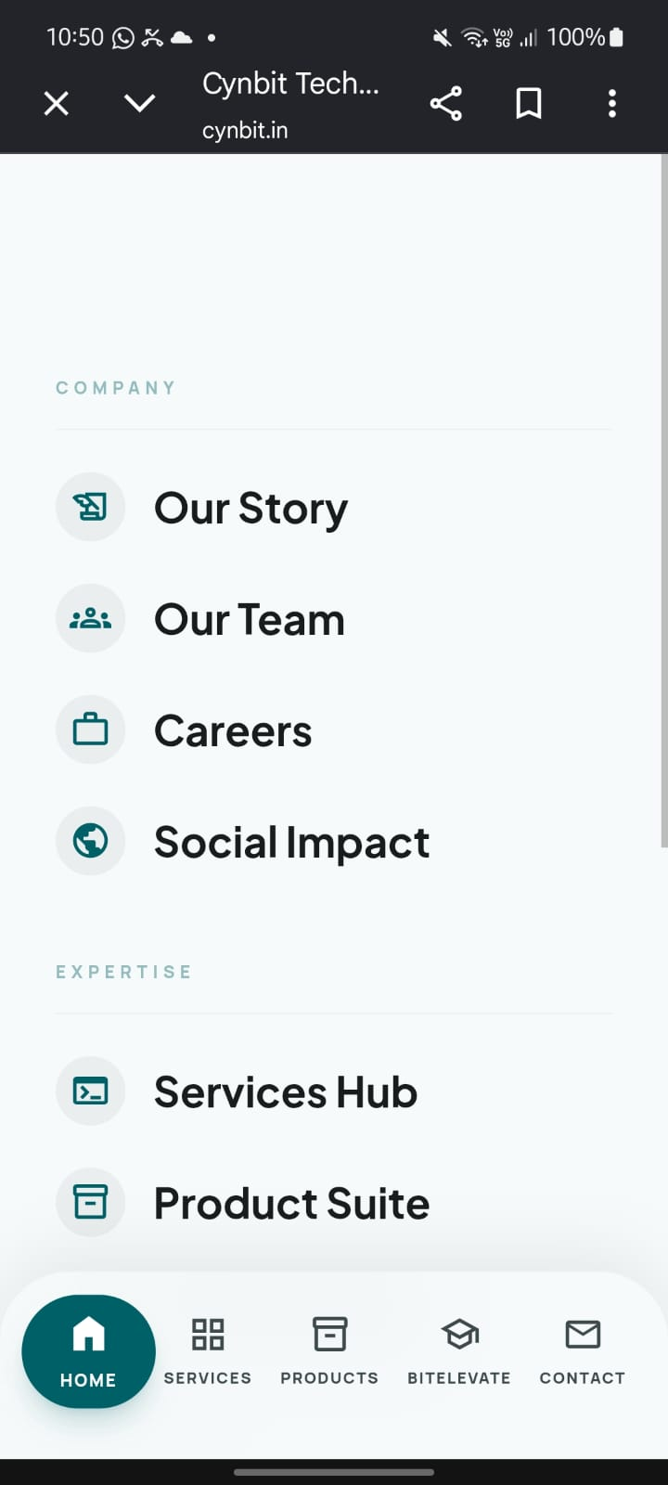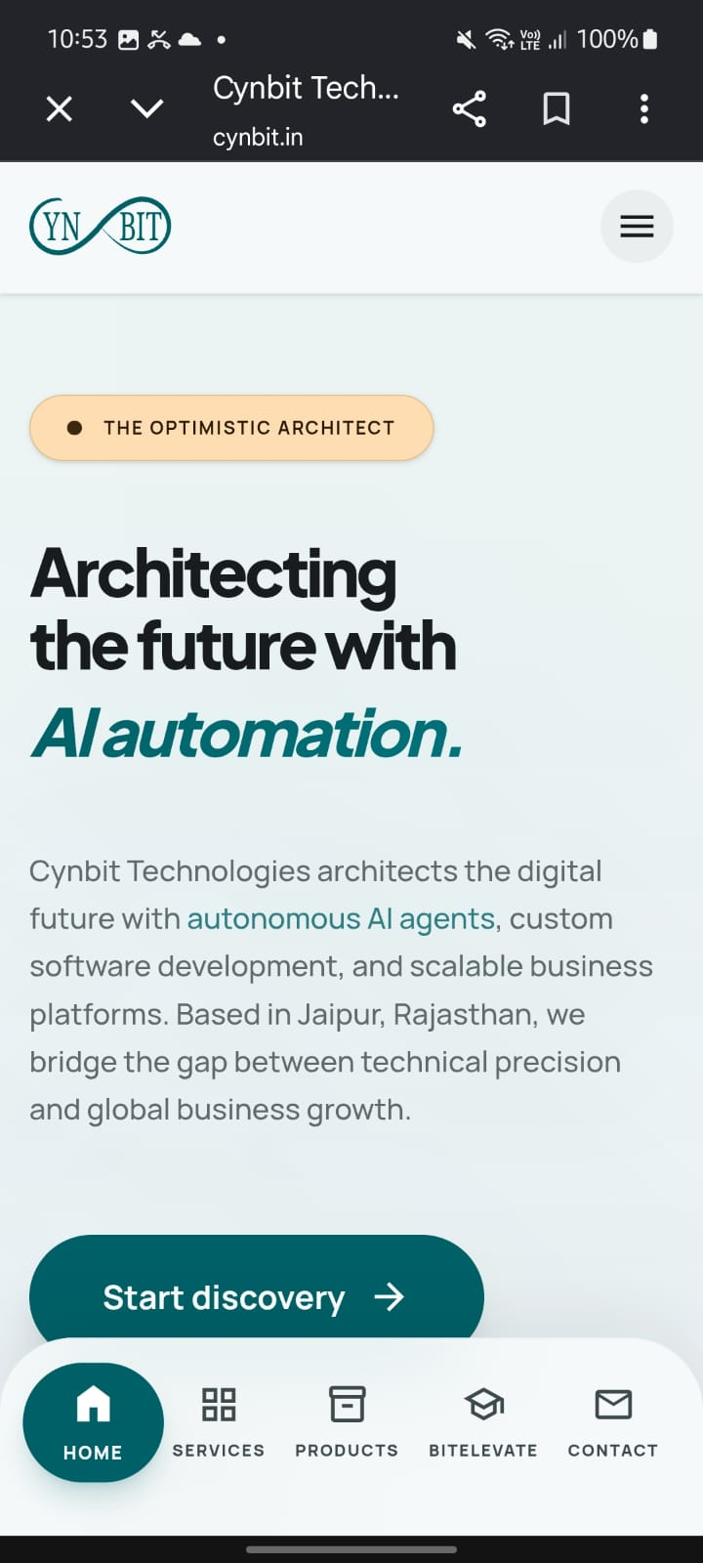

12. Final Note

This document is a preliminary audit report based on the observations recorded during the initial testing session. Tests that have not been executed are marked as Not Run. Further testing and verification are necessary before final sign-off.

